AWS CLOUD INFRASTRUCTURE
Elastic Load Balancing
A Hands-On Configuration & Deployment Guide
Classic • Application • Network Load Balancers
SSL/TLS • Route 53 DNS • S3 Access Logging

Prepared for: DevOps / Cloud Infrastructure Training
Document Type: Technical Task Report
July 2026

Table of Contents
Introduction 3
Task 1 Configure Classic Load Balancer 4
Task 2 Configure Application Load Balancer 7
Task 3 Configure Network Load Balancer 9
Task 4 Attach SSL for Application Load Balancer 13
Task 5 Map Application Load Balancer to Route 53 15
Task 6 Push Application Load Balancer Logs to S3 17
Conclusion 19

Introduction
Load balancing is a foundational technique for building highly available, fault-tolerant, and scalable applications in Amazon Web Services (AWS). Amazon Elastic Load Balancing (ELB) automatically distributes incoming application traffic across multiple targets, such as EC2 instances, in one or more Availability Zones, increasing the resilience of applications.
This report documents the step-by-step configuration of three types of AWS load balancers — Classic, Application, and Network — along with the setup of SSL/TLS termination, DNS mapping using Route 53, and centralized access-log storage in Amazon S3. Each task is accompanied by explanatory notes, configuration screenshots, and expected outcomes to serve as a complete, reproducible reference.

Scope of This Report
- Configuring a Classic Load Balancer (CLB) for basic HTTP traffic distribution
- Configuring an Application Load Balancer (ALB) with target groups
- Configuring a Network Load Balancer (NLB) for high-performance TCP traffic
- Attaching an SSL/TLS certificate to an ALB using AWS Certificate Manager
- Mapping an ALB to a custom domain using Route 53
- Enabling and verifying ALB access logs delivered to Amazon S3

Load Balancer Comparison
Feature | Classic (CLB) | Application (ALB) | Network (NLB)
OSI Layer | Layer 4 / 7 | Layer 7 | Layer 4
Protocol | HTTP, HTTPS, TCP | HTTP, HTTPS, WebSocket | TCP, UDP, TLS
Routing | Basic, single target group | Path/host-based, multiple target groups | Connection-based, static IP
Performance | Moderate | High | Ultra-high, low latency
Best Use Case | Legacy applications | Modern microservices, containers | High-throughput, latency-sensitive apps

TASK 1

Configure Classic Load Balancer
Distribute HTTP traffic across EC2 instances using AWS Classic Load Balancer

KEY CONCEPT
A Classic Load Balancer (CLB) is an AWS load balancer that distributes incoming traffic across multiple EC2 instances, improving high availability and fault tolerance. It automatically routes requests only to healthy instances using health checks.

1. Create the Load Balancer
- Navigate to EC2 → Load Balancers → Create Load Balancer → Classic Load Balancer.
- Enter a name, select Internet-facing, and choose IPv4 as the address type.
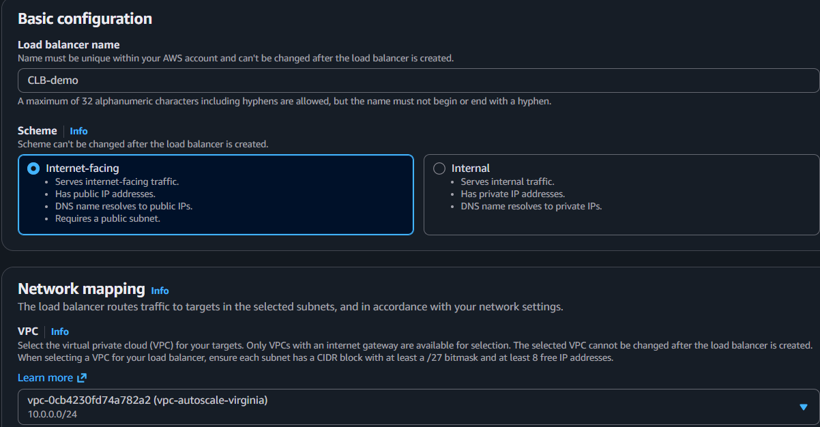
Figure 1.1 — Basic configuration: naming and scheme selection for the Classic Load Balancer
KEY CONCEPT
Internet-facing: Allows users to access the application from the public internet.
2. Select Network Placement
- Select the target VPC and choose 2 public subnets across 2 Availability Zones.
KEY CONCEPT
Public Subnets across 2 AZs provide high availability — if one Availability Zone fails, traffic is automatically routed through the other.
3. Configure the Listener
- Set the listener to forward HTTP : 80 → HTTP : 80.
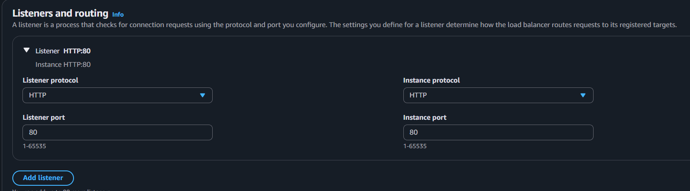
Figure 1.2 — Listener configuration mapping port 80 to port 80
KEY CONCEPT
A Listener receives client requests and forwards them to the registered EC2 instances.
4. Configure the Security Group
- Attach a security group that allows inbound HTTP traffic on port 80.
KEY CONCEPT
The Security Group acts as a virtual firewall controlling traffic allowed to reach the load balancer.
5. Configure the Health Check
- Set the health check protocol to HTTP, port 80, and path /.
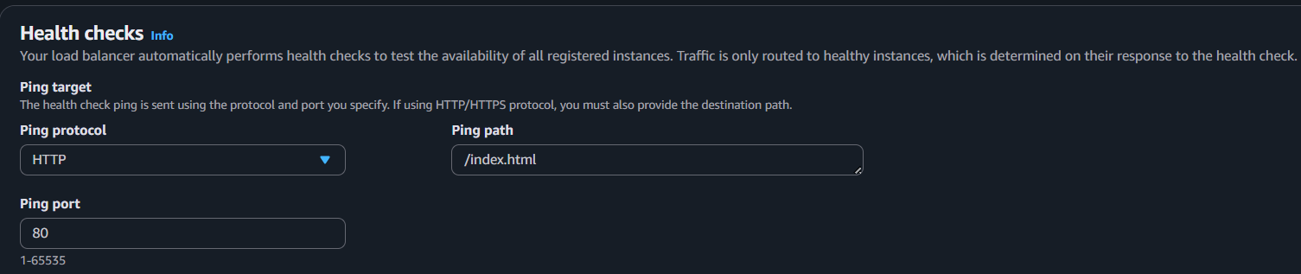
Figure 1.3 — Health check configuration for detecting healthy EC2 instances
KEY CONCEPT
The Health Check ensures traffic is sent only to EC2 instances that are responding correctly, automatically removing unhealthy instances from rotation.
6. Register Instances and Launch
- Register the target EC2 instance(s), review the configuration, and click Create.
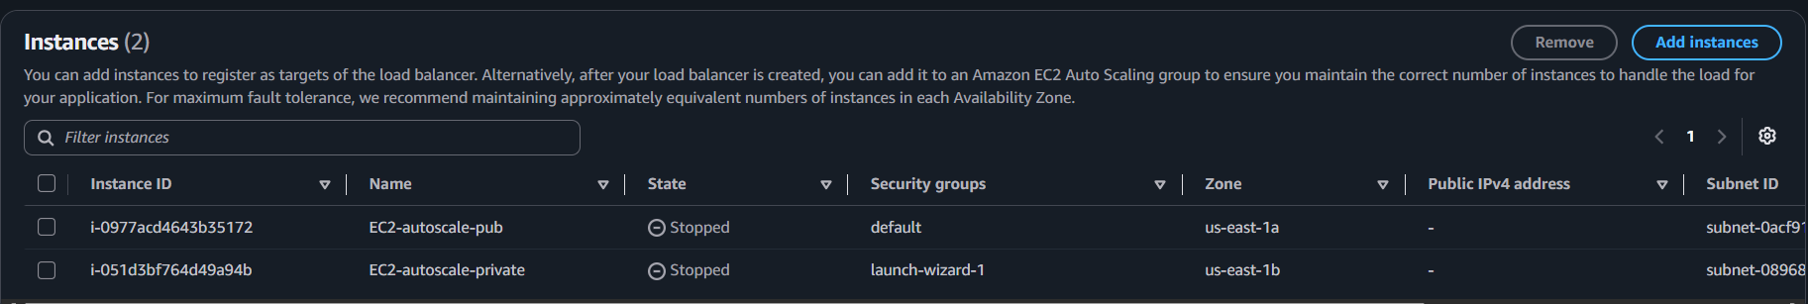
Figure 1.4 — Registered EC2 instances backing the Classic Load Balancer
KEY CONCEPT
Registered Instances are the backend servers that ultimately receive and process traffic forwarded by the load balancer.
7. Verify the Deployment
- Copy the CLB's public DNS name and open it in a browser to confirm the application responds successfully.
KEY CONCEPT
The DNS Name is the public endpoint clients use to reach the application through the load balancer.

TASK 2

Configure Application Load Balancer
Layer 7 routing for HTTP/HTTPS traffic with target group health monitoring

1. Create the Load Balancer
- Navigate to EC2 → Load Balancers → Create Load Balancer → Application Load Balancer.
- Enter a name, choose Internet-facing (public access), and select IPv4.
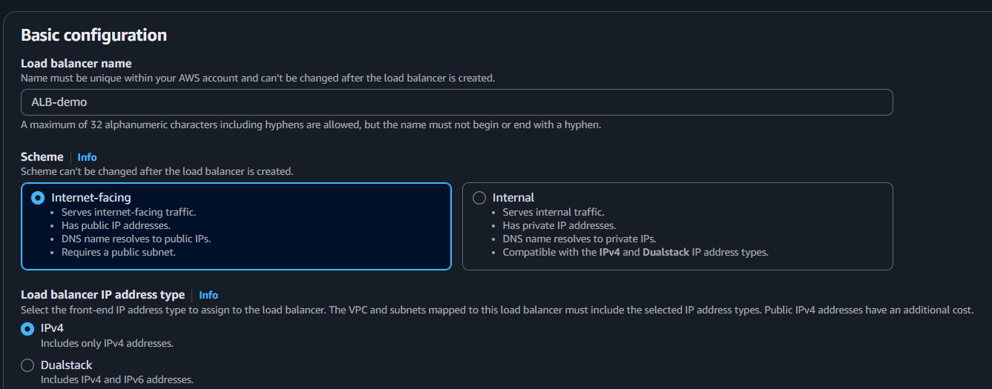
Figure 2.1 — Application Load Balancer basic configuration
2. Select Network Placement
- Select the VPC and 2 public subnets spanning 2 Availability Zones.
KEY CONCEPT
Deploying across multiple Availability Zones ensures the ALB remains available even if one zone experiences an outage.
3. Configure Security Group and Listener
- Security Group: allow inbound HTTP traffic on port 80.
- Listener: configure HTTP (80) to receive incoming client requests.
4. Create or Select a Target Group
- Choose target type: Instances.
- Set protocol to HTTP and port to 80.
- Register the EC2 instance(s) that will serve traffic.
KEY CONCEPT
The Target Group manages and continuously monitors the health of the backend EC2 instances behind the ALB.
5. Review and Create
- Review the full configuration summary and click Create Load Balancer.
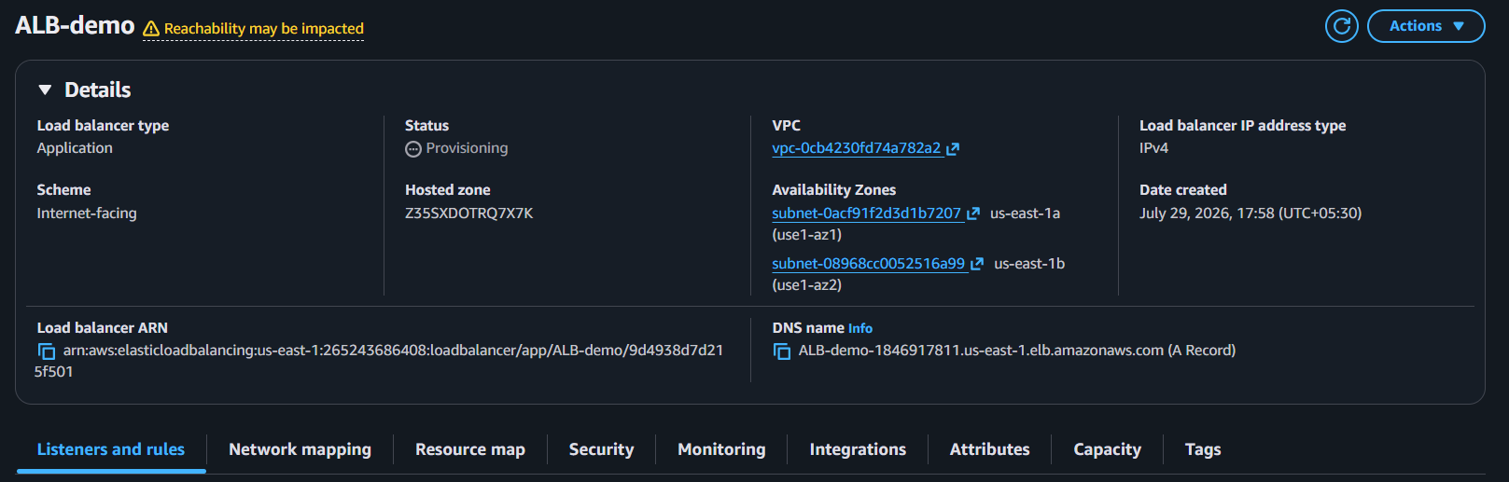
Figure 2.2 — Final review before creating the Application Load Balancer
6. Test the Application Load Balancer
- Open the ALB's DNS name in a browser to confirm the application is accessible.

Figure 2.3 — Successful response confirming the ALB is routing traffic correctly
RESULT
The Application Load Balancer distributes incoming HTTP requests only to healthy EC2 instances registered in the Target Group.

TASK 3

Configure Network Load Balancer
Ultra-low latency Layer 4 load balancing for TCP/UDP traffic

1. Create the Load Balancer
- Navigate to EC2 → Load Balancers → Create Load Balancer → Network Load Balancer.
- Enter a name, choose Internet-facing (public access), and select IPv4.
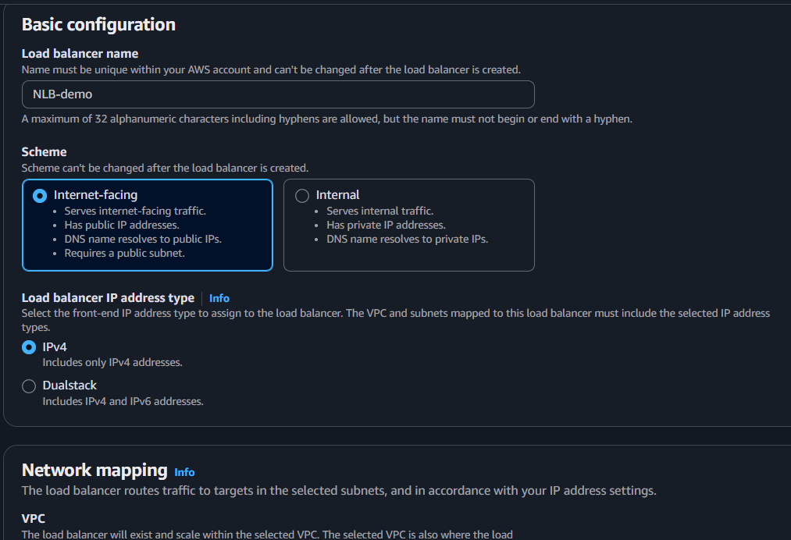
Figure 3.1 — Network Load Balancer basic configuration
2. Select Network Placement
- Select the VPC and 2 public subnets across 2 Availability Zones.
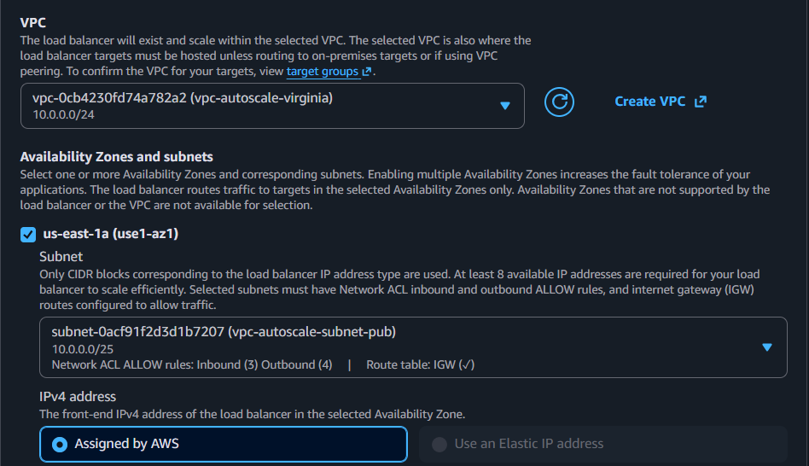
Figure 3.2 — Multi-AZ subnet mapping for the NLB
KEY CONCEPT
Deploying the NLB across multiple Availability Zones provides fault tolerance and high availability at the network layer.
3. Configure the Listener and Security
- Listener: configure TCP (80) to receive raw network traffic.
- Select or create the required target group.
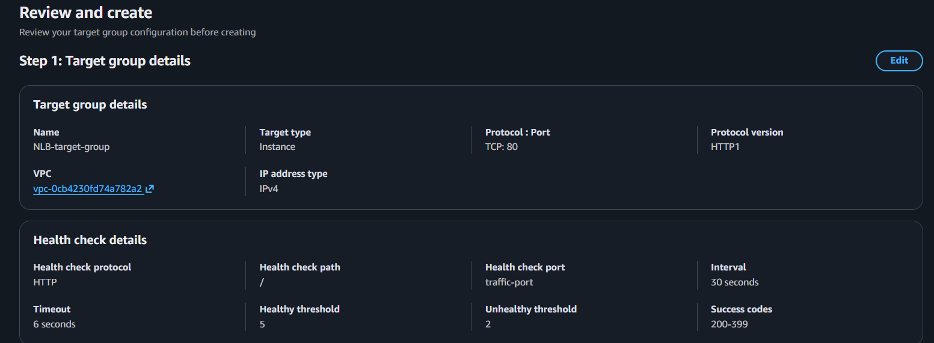
Figure 3.3 — TCP listener and target group selection
4. Create or Select a Target Group
- Target type: Instances.
- Protocol: TCP, Port: 80.
- Register the EC2 instance(s).
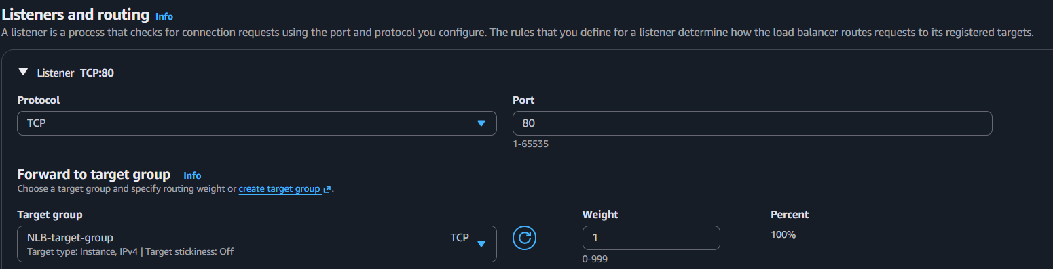
Figure 3.4 — Target group registration for the NLB
KEY CONCEPT
The Target Group routes traffic directly to healthy backend instances with minimal overhead, preserving low latency.
5. Review and Create
- Review the configuration and click Create Load Balancer.
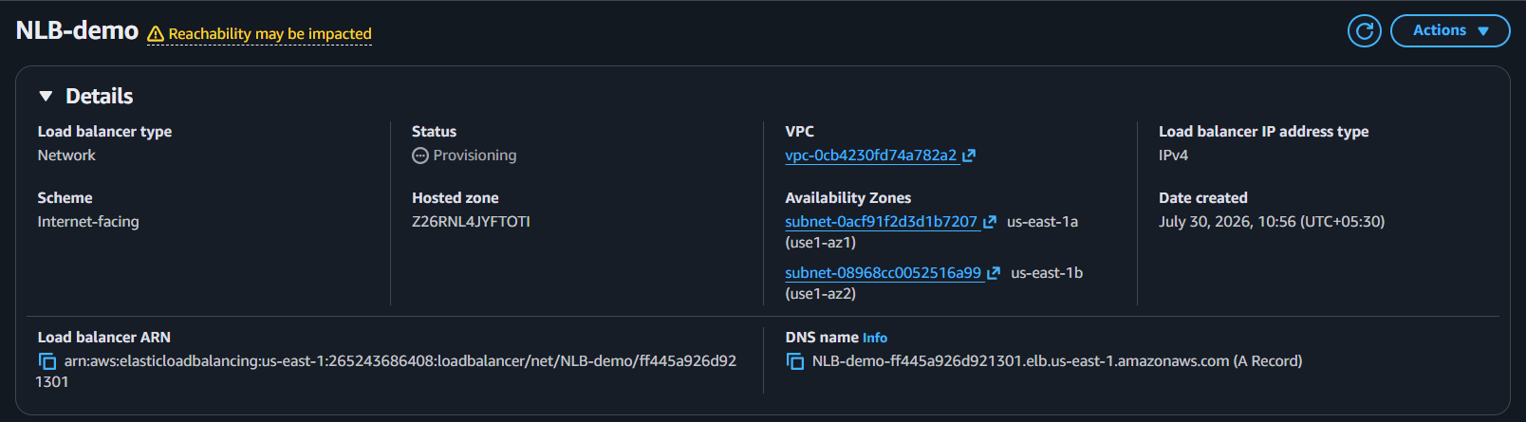
Figure 3.5 — Final review before creating the Network Load Balancer
6. Test the Network Load Balancer
- Open the NLB's DNS name in a browser to verify the application is accessible.
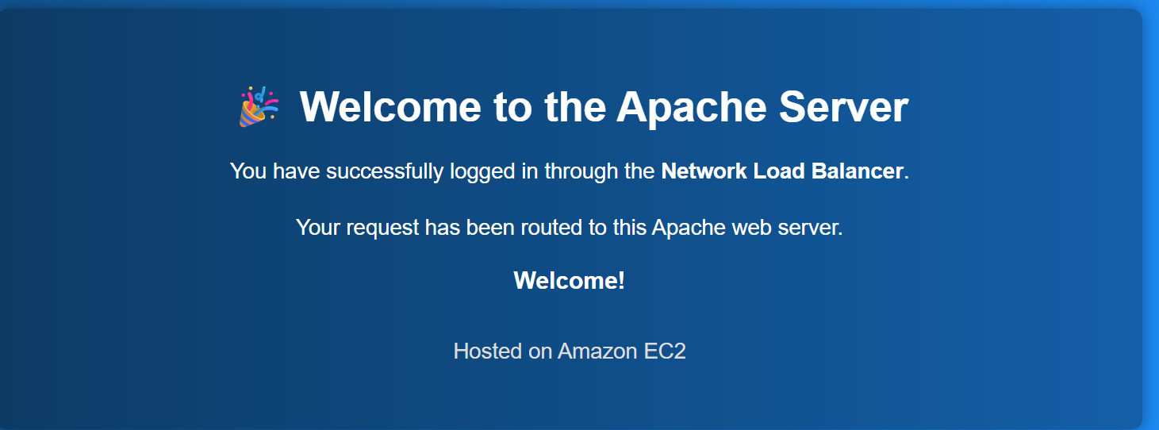
Figure 3.6 — Verified connectivity through the Network Load Balancer
RESULT
The Network Load Balancer distributes TCP/UDP traffic to healthy EC2 instances with high performance and low latency.

TASK 4

Attach SSL for Application Load Balancer
Enable HTTPS termination using AWS Certificate Manager

1. Request an SSL Certificate
- Open AWS Certificate Manager (ACM).
- Click Request → Request a public certificate.
- Enter the domain name (e.g., example.com or *.example.com).
- Validate ownership using DNS validation (recommended).
- Wait until the certificate status changes to Issued.
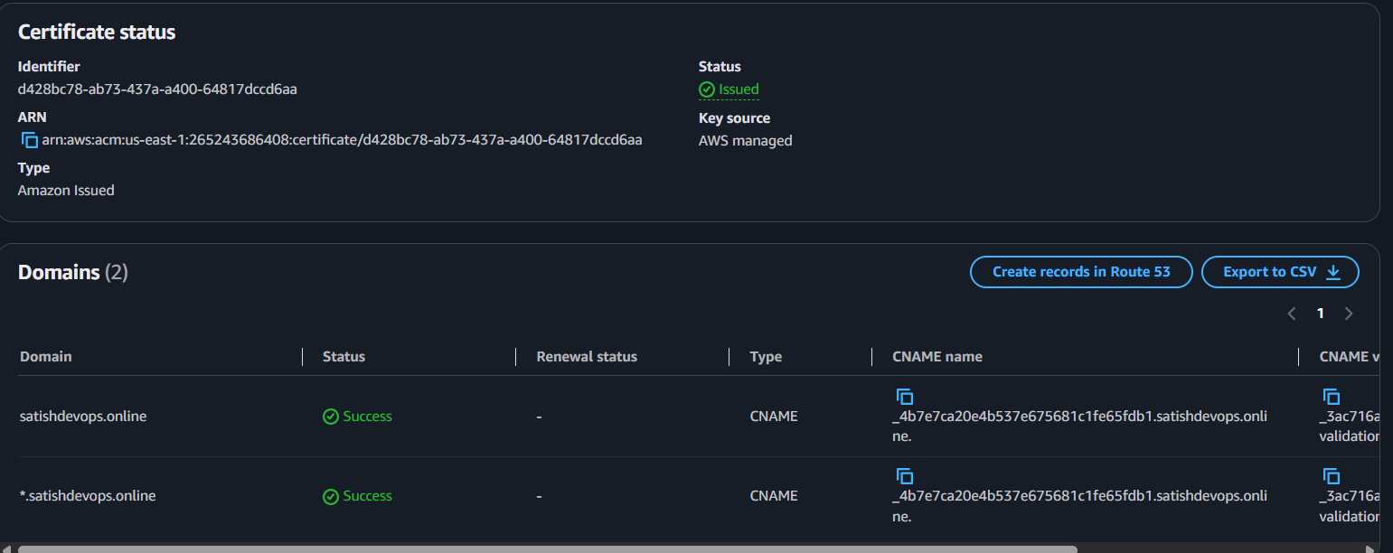
Figure 4.1 — SSL certificate issued in AWS Certificate Manager
2. Open the Target Load Balancer
- Navigate to EC2 → Load Balancers and select the Application Load Balancer.
3. Add an HTTPS Listener
- Go to the Listeners and rules tab and click Add listener.
- Select HTTPS (443) as the protocol.
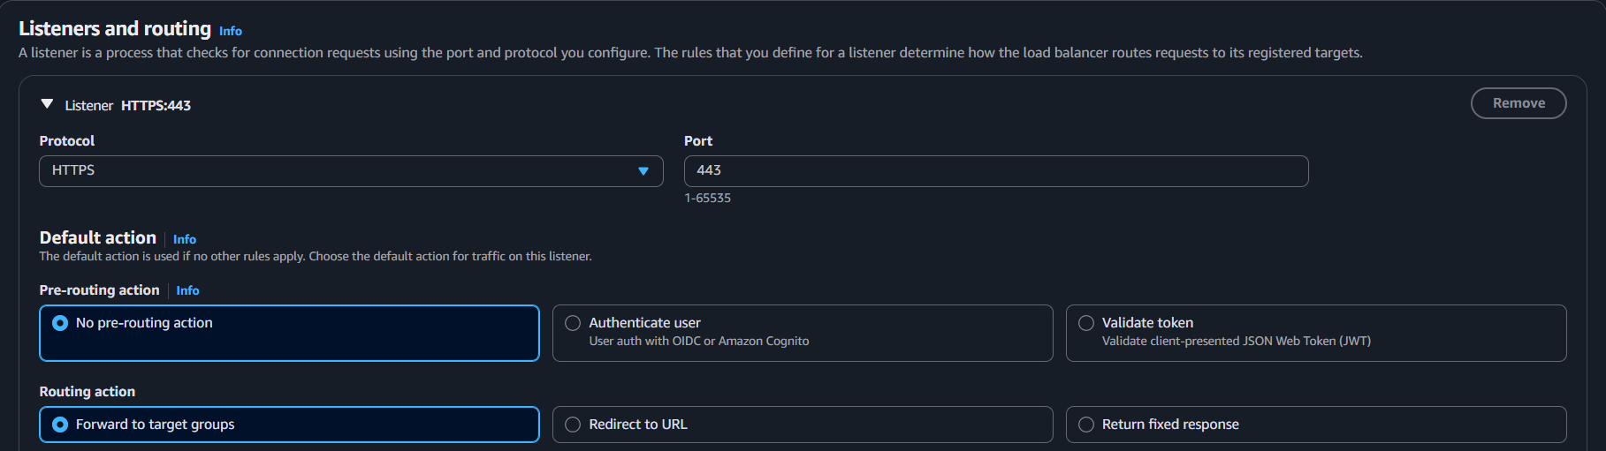
Figure 4.2 — Adding an HTTPS listener on port 443
4. Attach the SSL Certificate
- Under Secure listener settings, choose From ACM.
- Select the issued SSL certificate.
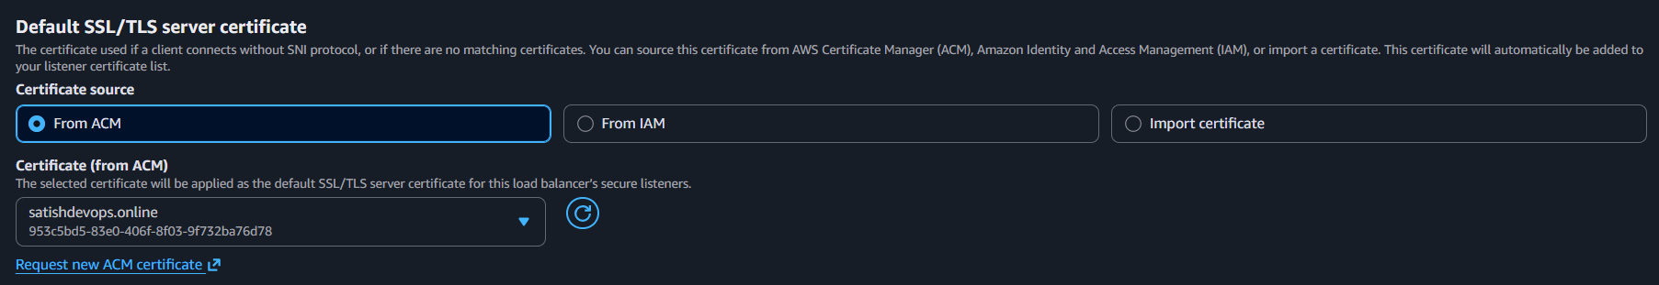
Figure 4.3 — Attaching the ACM-issued certificate to the listener
5. Configure the Default Action
- Choose the target group that serves the application.
- Click Add listener or Save.
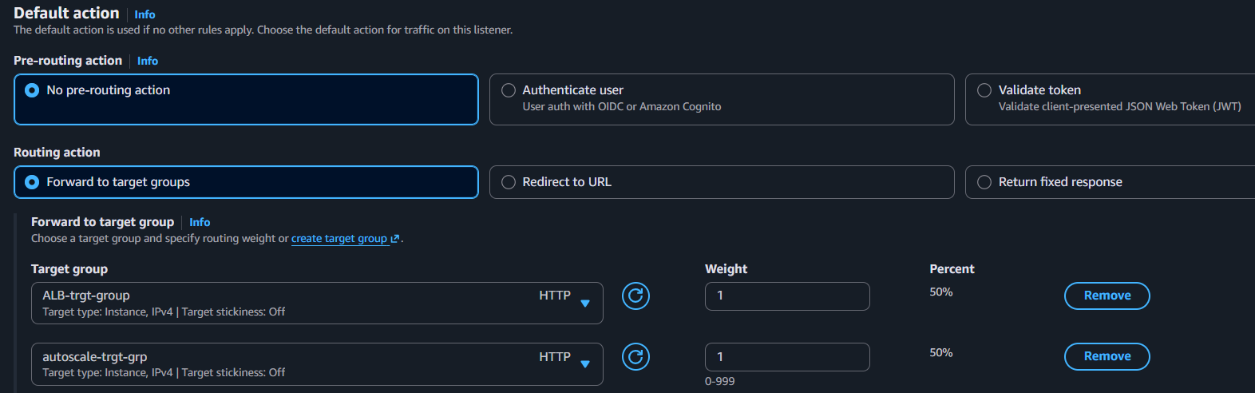
Figure 4.4 — Default action configured to forward to the target group
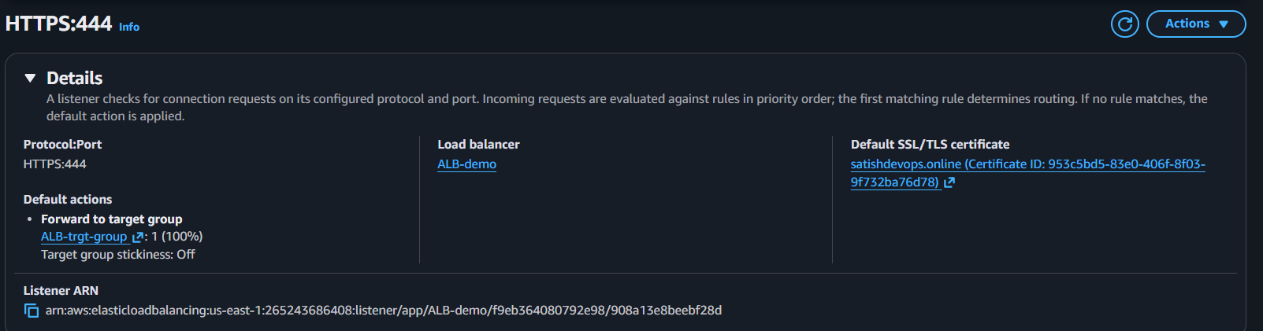
Figure 4.5 — HTTPS listener successfully added to the Application Load Balancer
RESULT
The Application Load Balancer now terminates SSL/TLS on port 443, encrypting traffic between clients and AWS while forwarding requests to the backend target group.

TASK 5

Map Application Load Balancer to Route 53
Point a custom domain to the ALB using an alias record

1. Open the Hosted Zone
- Open AWS Console → Route 53 → Hosted Zones.
- Select the hosted zone for the target domain (e.g., satishdevops.online).
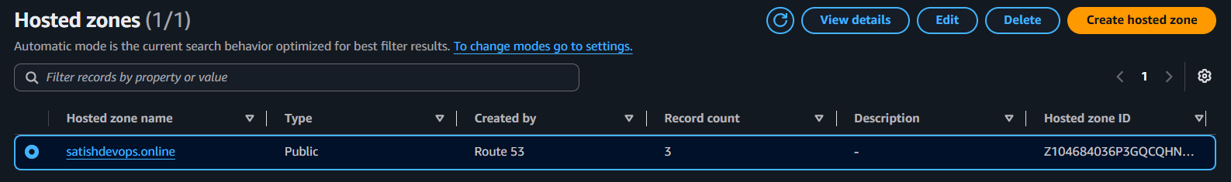
Figure 5.1 — Route 53 hosted zone overview
2. Create the DNS Record
- Click Create record.
- Record name: leave blank, or enter www if required.
- Record type: A – IPv4 address.
- Alias: Enable.
- Route traffic to: Alias to Application and Classic Load Balancer.
- Region: us-east-1 (N. Virginia).
- Choose Load Balancer: select the target ALB.
- Routing policy: Simple routing.
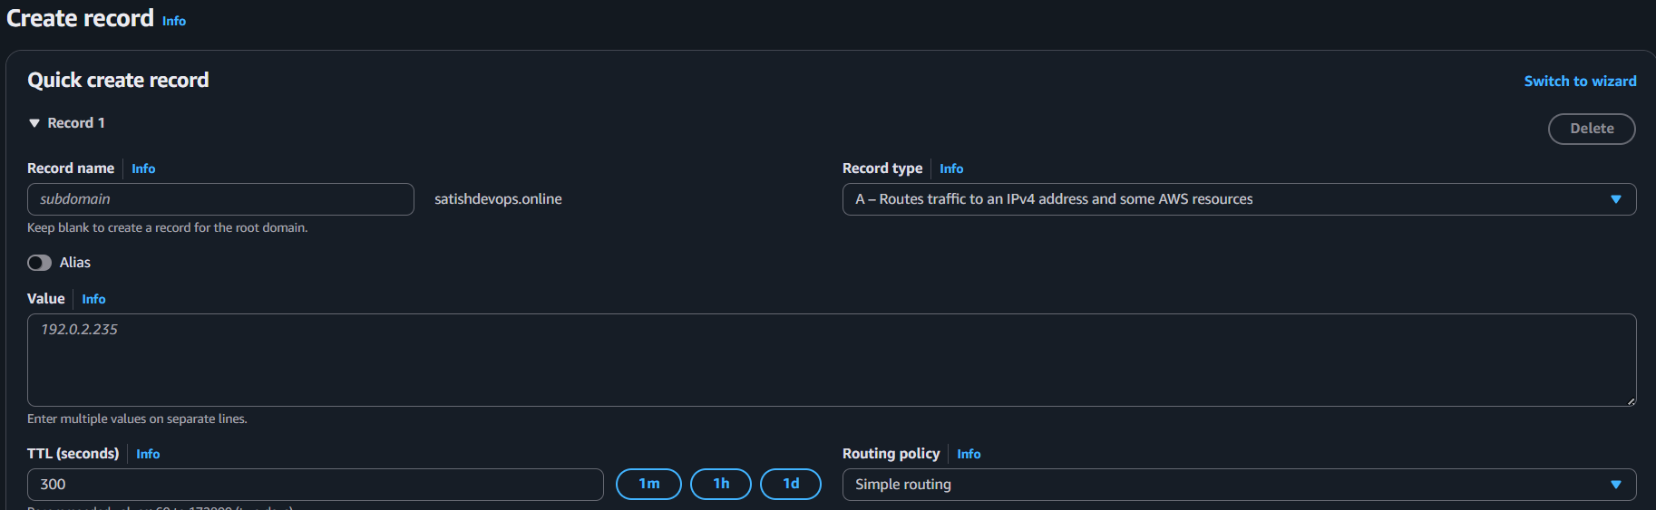
Figure 5.2 — Alias record configuration pointing to the ALB
3. Create the Record
- Click Create records to finalize the DNS mapping.
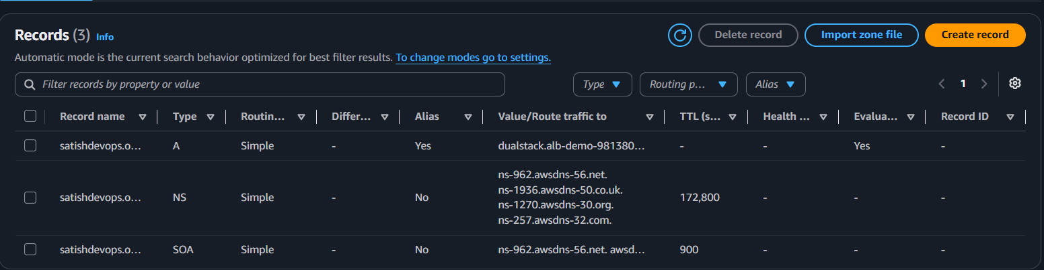
Figure 5.3 — DNS record successfully created in the hosted zone
4. Verify DNS Propagation
- Wait a few minutes for DNS propagation to complete.
- Test by opening the custom domain in a browser.
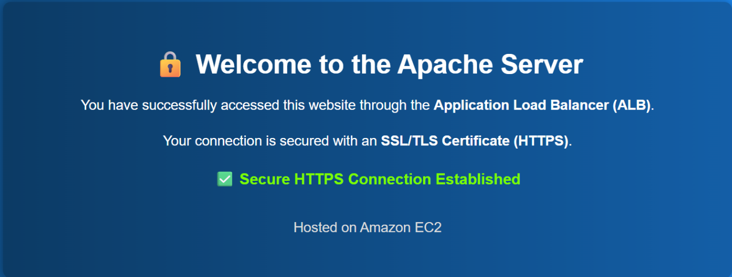
Figure 5.4 — Application successfully reachable via the custom domain
RESULT
The custom domain now resolves directly to the Application Load Balancer, allowing users to access the application over a friendly, branded URL.

TASK 6

Push Application Load Balancer Logs to S3
Enable centralized access logging for auditing and troubleshooting

Step 1. Create an S3 Bucket
- Go to S3 → Create bucket.
- Enter a unique bucket name.
- Create the bucket.
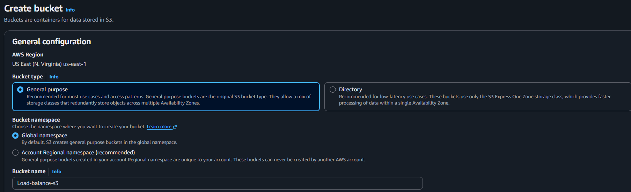
Figure 6.1 — New S3 bucket created for storing ALB access logs
Step 2. Add a Bucket Policy
- Open the bucket → Permissions → Bucket Policy.
- Add the AWS-recommended ALB access-log policy, replacing the bucket name and account ID as needed.
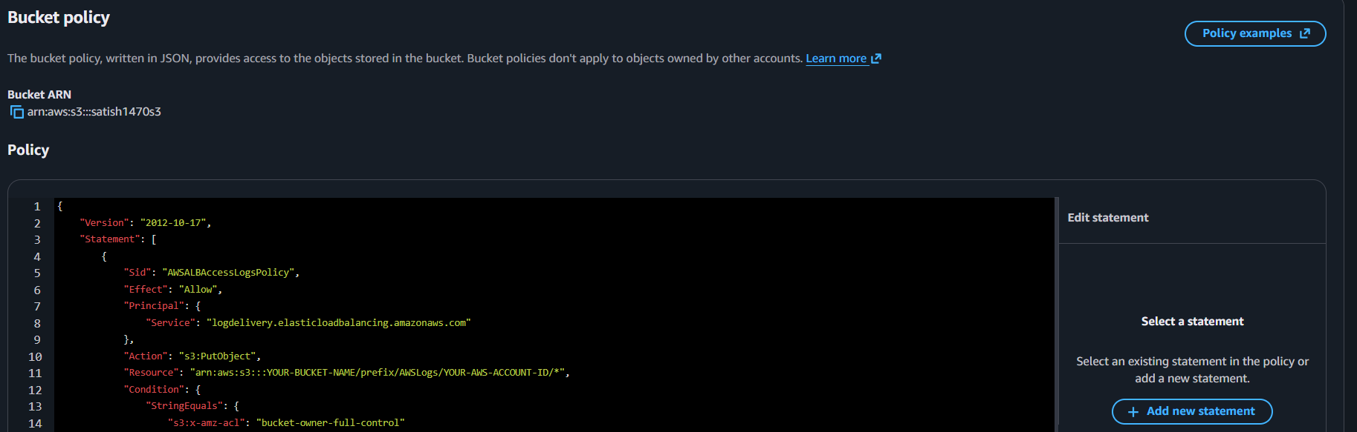
Figure 6.2 — Bucket policy granting the ALB permission to write logs
Step 3. Enable Access Logs on the ALB
- Go to EC2 → Load Balancers and select the Application Load Balancer.
- Open the Attributes tab and click Edit.
Step 4. Enable Logging
- Enable Access logs.
- Select the target S3 bucket.
- (Optional) Enter a prefix, e.g., alb-logs/.
- Click Save changes.
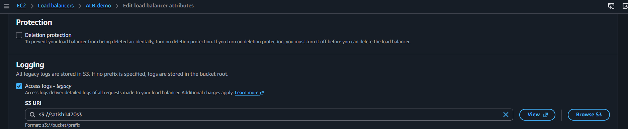
Figure 6.3 — Access logging enabled and pointed to the S3 bucket
Step 5. Generate Traffic
- Open the website through the ALB several times to generate log entries (e.g., https://satishdevops.online).
Step 6. Verify the Logs
- Go to S3 → the target bucket and open the configured prefix, if any.
- Confirm that ALB log files have been created.
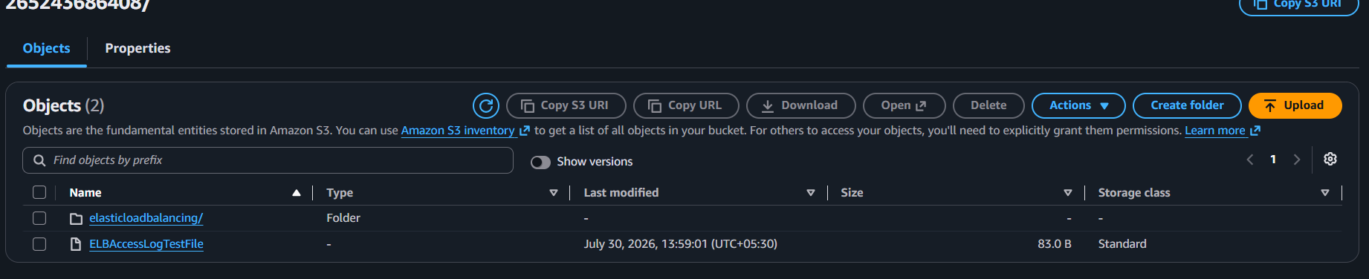
Figure 6.4 — ALB log files delivered to the S3 bucket
RESULT
Access logs from the Application Load Balancer are now automatically delivered to Amazon S3, enabling long-term storage, auditing, and traffic analysis.

Conclusion
This report has demonstrated a complete, end-to-end configuration of AWS Elastic Load Balancing, covering all three load balancer types, secure traffic termination with SSL/TLS, custom DNS routing through Route 53, and centralized log delivery to Amazon S3.
Together, these configurations establish a production-ready foundation for distributing traffic reliably, securing communications, and maintaining visibility into application traffic patterns — all essential practices for operating resilient cloud infrastructure on AWS.

Key Takeaways
- Classic Load Balancers suit simple, legacy HTTP/TCP workloads.
- Application Load Balancers provide intelligent Layer 7 routing ideal for modern, microservice-based applications.
- Network Load Balancers deliver ultra-low latency Layer 4 performance for high-throughput workloads.
- SSL/TLS termination on the ALB secures data in transit between clients and the application.
- Route 53 alias records provide seamless, branded domain access to load-balanced applications.
- S3-based access logging enables auditing, troubleshooting, and long-term traffic analysis.

